**How to run test scripts**:

* make sure you are in the root directory of the folder after creating the virtual environment.
* First you need to run the flask application by typing python app.py in the terminal.
* Then create a new terminal navigate back to the root directory of the folder and activate the virtual environment again: (Activate the virtual environment by running the following command: **source venv/bin/activate** or **venv\Scripts\activate**
* After activating the virtual environment use py name_of_test_script to run the test script

**Register and login testing:**

**Login_register_endtesting.py**

* Automates the testing of both registration and simultaneous login
* Database is cleared so that if you run the test more than once the user will not already be registered
* Script starts on the /register page locates all required field and submits dummy data
* After submitting it waits for redirection to the /login page and enters the users data there as well
* If we are successful we will land on the / page which is the homepage

**Login and Booking History Testing:**

**login_booking_e2e_testing.py**

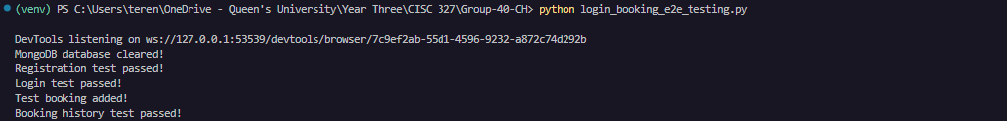

**Features Considered for Testing:**

1. User Registration: Automates the registration process to ensure a new user can register and test with the log in functionality.
2. User Login:  Automates the login process to verify a registered user can log in.
3. Booking Addition: Adds a booking for the test user directly to the database.
4. Booking History: Checking the booking history page displays correct information for the logged-in user.

The scripts start on the registration page to add a new user to the database for testing with the login page. After redirecting to the /login page, the user information is filled out and submitted, leading to the flight search page. A new booking is then added, and a redirection to /booking-history occurs to check that the booking history is properly displayed.